**DSCI 551 LAB2**

**Jiahao Sun**

-ls

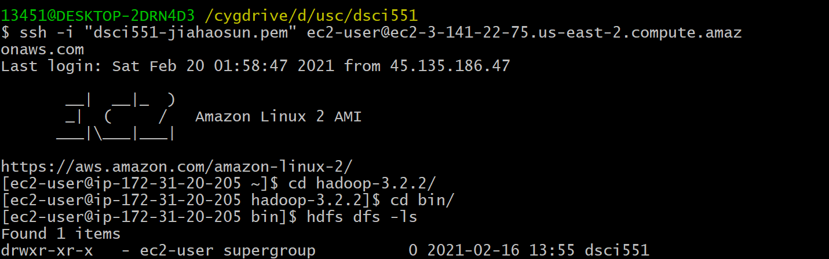

‘drwxr-xr-x’ indicates the authority of the file.

‘d’ means that it is a direction file. ‘rwx’ means that the owner of the file can read, write and execute this file. The first ‘r-x’ means that the users in the same group can read and execute this file but can not write. The second ‘r-x’ means that other users has the same authority with the users in the same group.

-mkdir

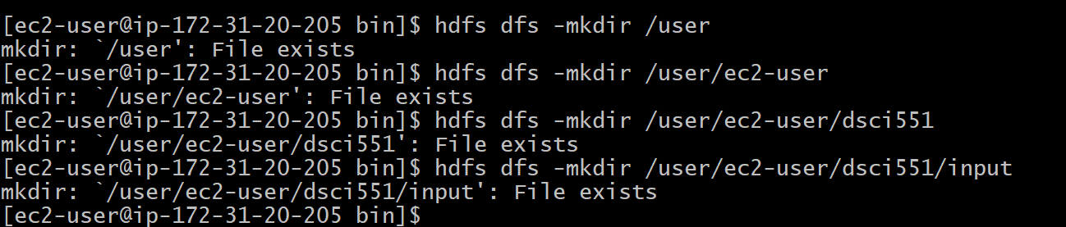

-rmdir

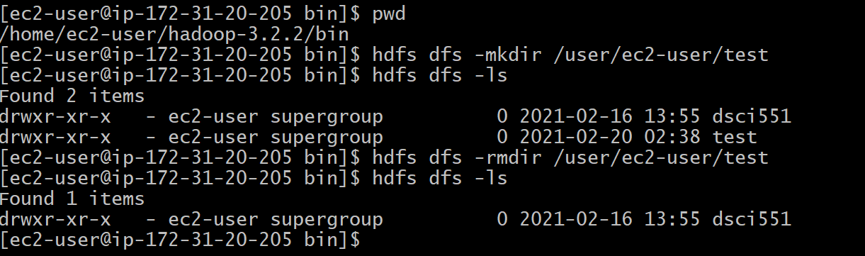

-put

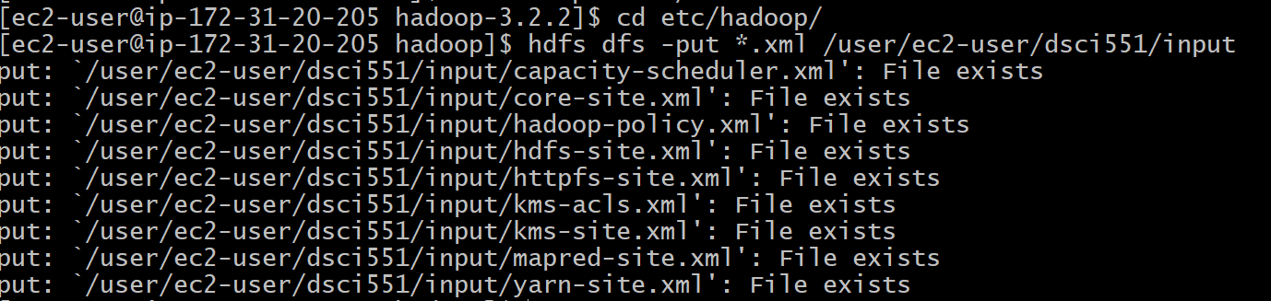

-get

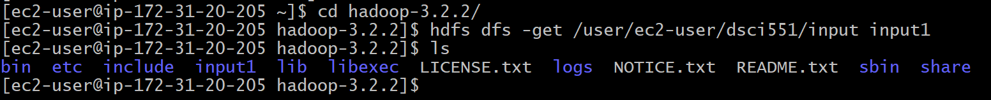

-rm



-cp



-chmod



-appendTofile&cat

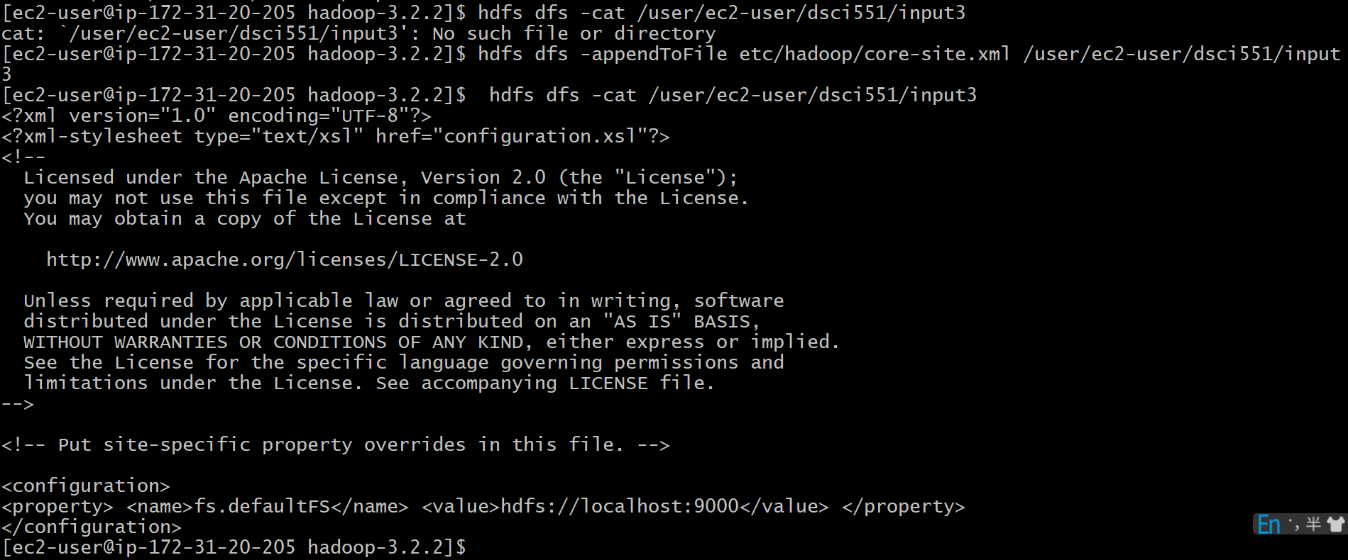

-cat

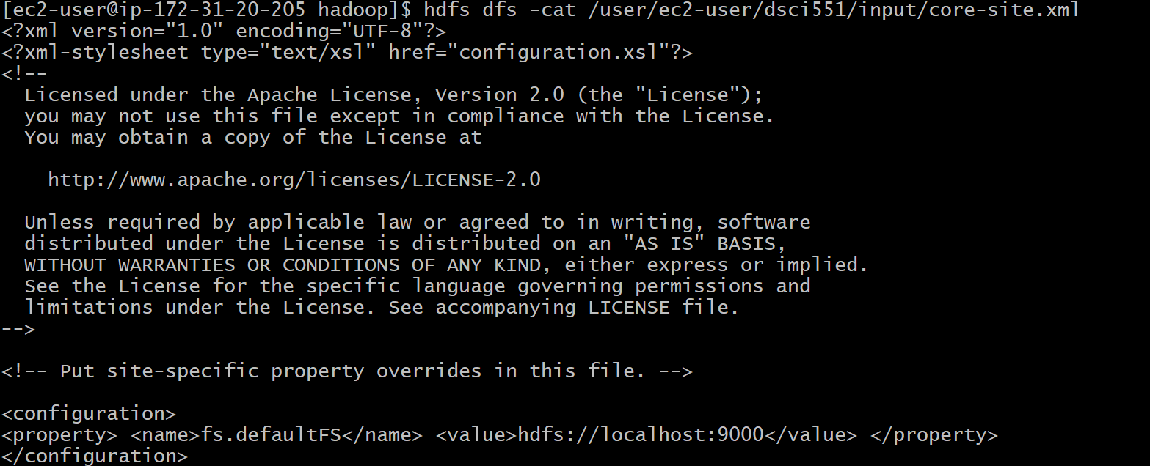

-stat



Type of the file,

Permission is 644.

Usergroup is supergroup.

Size 860.

Modify time and access time is 2021-02-20 05:11:11.

Name of the file is ‘input3’.